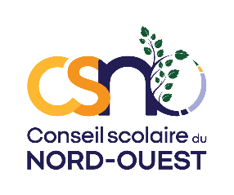 | DA 260B - ANG

AUTHORIZATION FORM
Educational Trips

Activity: ___________________________________________________________________________
School: _____________________________________ Date of activity: _________________________
Teacher Responsible: ________________________________________________________________

Please read the activity information sheet before completing this form
Student Name:______________________________________________________________________________

Responsibilities of the School Board
The CSNO will make all reasonable efforts to ensure that:
- The personnel, volunteers and/or instructors offering this activity are qualified;
- The students are supervised adequately during the entire activity;
- The location of this activity is appropriate and safe;
- The equipment used during this activity is properly inspected, appropriate and safe.

Potential Risks
The potential risks associated with this activity may include: ______________________________________________

Acknowledgement of Risk
- I understand my right to obtain information regarding this activity beyond that which has been provided to me by the school, and I understand the risks associated with this activity.
- I understand the risks associated with this activity and recognize that my child can be seriously injured because of unforeseeable circumstances associated with participation in this activity.
- My child is informed of and must obey all rules throughout this activity including the guidelines and instructions of school personnel and the instructors of the organization providing this activity.
- If my child does not obey the rules, disciplinary measures will be taken which may include his/her exclusion from the activity, or I may be contacted to collect my child.
- I understand my responsibility to provide the school with all pertinent medical information regarding the participation of my child in this activity.
- I give my consent to CSNO personnel to obtain medical advice or access medical interventions which they deem necessary to ensure the health and safety of my child, and I accept the financial responsibility thereof.
- I understand that CSNO carries basic accident insurance for its students and does not carry life, disability or medical insurance. Life, disability and medical insurance for my child are solely my responsibility.
- I understand and accept the above and give my child _______________________permission to participate in this activity.

Name of parent/guardian (please print) _______________________________________________________

Signature of parent/guardian______________________________ Date _____________________

